VARSITY COLLEGE DURBAN NORTH OPSC7312

DURAN MOODLEY 13016335

Assignment 2 - POE

Contents

Introduction 2

Program Specification 2

Game Description 2

Functionality 2

System Requirements 3

Flow Chart 5

UML Diagrams 10

Use Case Diagram 10

Class Diagram 10

Sequence Diagram 13

Database Design 14

ERD Diagram 14

Table Structure 14

Help File 14

Screenshots 15

Lecturer Feedback & Corrections Made 24

Conclusion 24

Problem Statement

By Duran Moodley

# Introduction

A Non-government organization LIVE is in desperate need of funds to support their growth and development. They would like an interactive game that can draw the attention of people and other companies to submit donations.

# Program Specification

## Game Description

This game makes use of graphics, user gestures and motion. The aim of the game is to catch the BLUE and GREEN dots has many times as possible in a certain time. When the game starts the user will be shown a black screen. To start, the user will need to drag his/her finger. A Black dot will follow the user’s finger as he/she drags their finger. The user must ensure that he drags the Black dot onto either the Blue or Green dot. Once the user catches the dot a point will be added. The dots will randomly appear on different areas of the screen. 1 Point will be awarded for a Blue dot and 10 Points will be awarded for the Green Dot. However, catching/touching any other dot will result in points being deducted. (Yellow Dot = -10 Points, Red Dot = -1 Point, Gray Dot = -50 Points). This process will continue to occur. Every Level will require a certain amount points to be achieved in order to proceed to the next level. This is your target level points. Successfully achieving these targets points for that level will add on a Bonus 20 points. When the user reaches and successfully completes the last level an additional 50 points will be awarded. The user’s points and scores will be saved to a database and can be viewed on the app. Every user will need to enter in a valid email address for identification. A username will be generated which will keep track of all users playing the game as well as score rankings.

## Functionality

* Graphics
* Drawing on a canvas
* Tracking user gesture and motion
* Saving data to an online MYSQL Database
* Reading a JSON Feed
* Creating and Calling Stored procedures in Awards Space.
* Using Material Design
* Saving/Reading Data from Shared preferences and a text file

## System Requirements

**Main Screen**

*This Screen Contains Game Options for the Player to select. These options include: Play Game, How to Play and World Rankings. This activity also captures the users email address for identification purposes and shows the player their current overall score. This data is saved to a shared preference and sent to the MYSQL online database.*

**Play *Game***

*The player can start the game by selecting this option. You will be shown a Black Screen.*

*Dragging your finger will start the game.*

*When dragging your finger, you will find a Black Dot will follow your finger on the Screen.*

*You need to drag your BLACK Dot onto the BLUE or GREEN Dot that you will see appear on different locations on the screen.*

*You must not to touch the other Dots that Appear.*

*The Points Scheme are as follows:*

*Blue Dot = 1 Point*

*Green Dot = 10 Points;*

*Yellow Dot = -10 Points;*

*Red Dot = -1 Point;*

*Gray Dot = -50 Points;*

*At the start you will get a Target of Points to get.*

*If you successfully get the specified Target Points for that Level, You will get a Bonus 20 Points.*

*Successfully Completing the Last Level will Award you an Extra 50 Points.*

*The players score is accumulated after every level. This data will eventually update the players overall score tally in the MYSQL online database.*

**How to Play**

*Data is retrieved from a text file which gives instructions of how to play the game.*

**World Rankings**

*Data is retrieve from a MYSQL database. This contains the positions of everyone who’s playing the game. The player’s username, positions and score is shown in a list view.*

**About LIV**

*Data is retrieve from a text file which gives details about LIV and what they stand for as an NGO. A Floating action bar can be used to redirect to the web page of LIV by simply clicking on it.*

**Donate**

*Data is retrieved from a text file which gives instructions of how to donate and what methods a user can use. A Floating action bar can be used to redirect to the web page of LIV by simply clicking on it.*

**Volunteer Your Skills**

*This provides information of how to become a volunteer and what skills be used. A Floating action bar can be used to redirect to the web page of LIV by simply clicking on it.*

**Corporate Team Building**

*Gives information how the social investment opportunity that LIV provides. A Floating action bar can be used to redirect to the web page of LIV by simply clicking on it.*

**Get in Touch**

*Give details of how to contact the organisation and the address. A Floating action bar can be used to redirect to their face book page.*

# Flow Chart

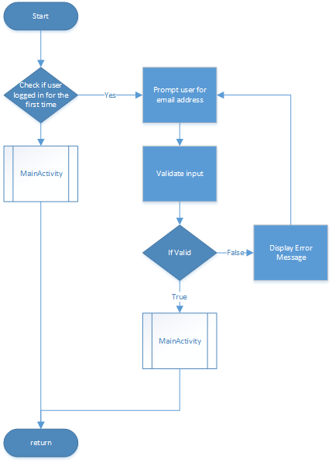

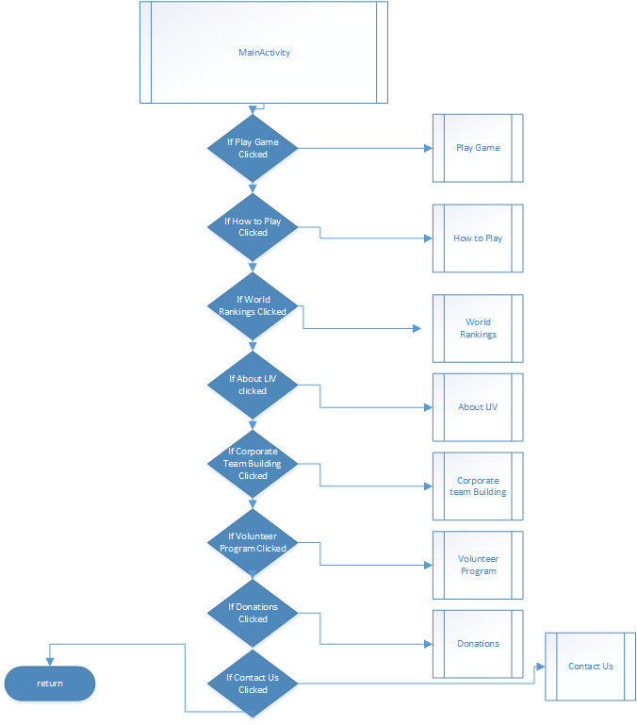

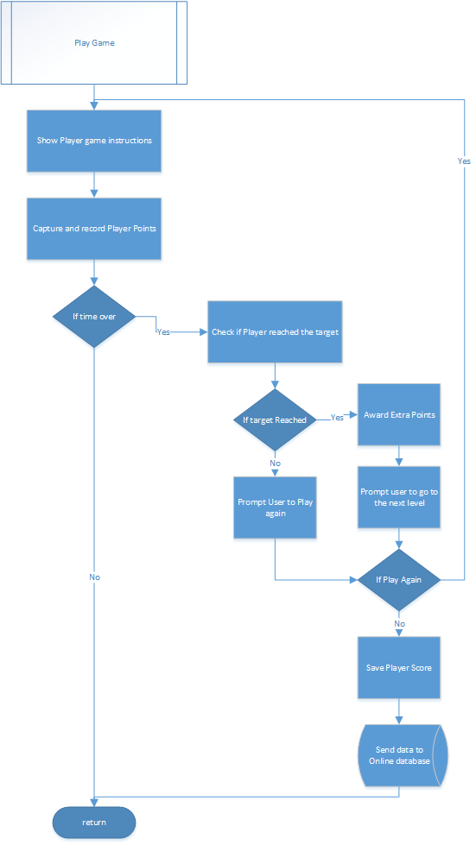

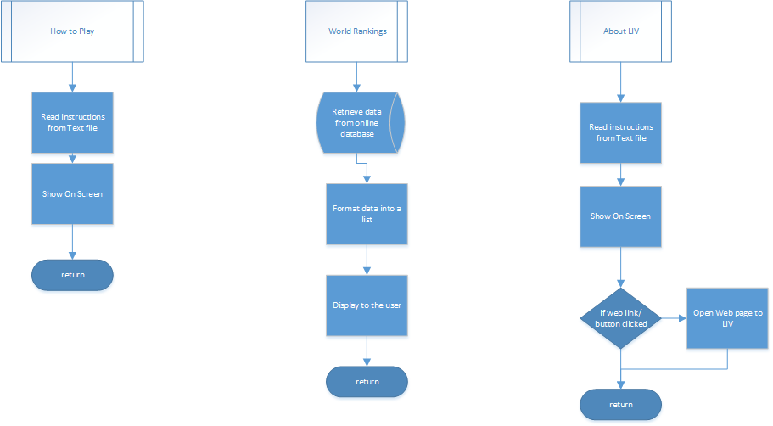

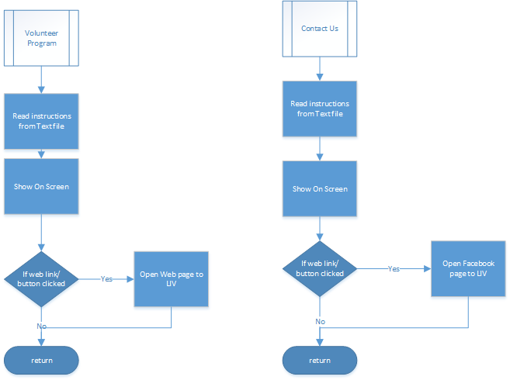

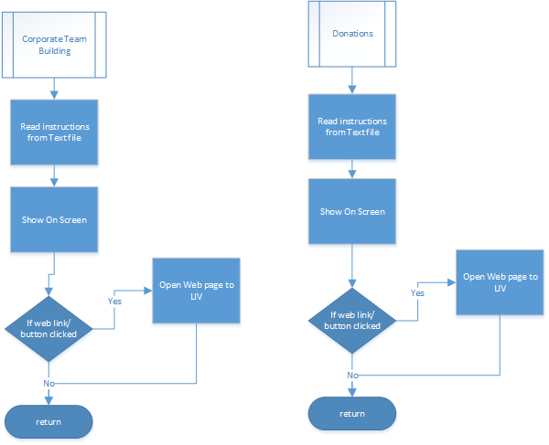

# UML Diagrams

## Use Case Diagram



## Class Diagram







## Sequence Diagram



# Database Design

## ERD Diagram



## Table Structure

|  |  |
| --- | --- |
| Username{PK} | score |
| duranmoodley97 | 1000 |
| andreames08 | 50 |
| magaretthoms79 | 999 |
| derekbestel98 | 5000 |

# Help File

The aim of the Game is simple.

To start playing you need to select the Play Game option on the Game Menu.

You will be shown a Black Screen.

Dragging your finger will start the game.

When dragging your finger, you will find a Black Dot will follow your finger on the Screen.

You need to drag your BLACK Dot onto the BLUE or GREEN Dot that you will see appear on different locations on the screen.

You must not to touch the other Dots that Appear.

The Points Scheme are as follows:

Blue Dot = 1 Point

Green Dot = 10 Points;

Yellow Dot = -10 Points;

Red Dot = -1 Point;

Gray Dot = -50 Points;

At the start you will get a Target of Points to get.

If you successfully get the specified Target Points for that level, You will get a Bonus 20 Points.

Successfully Completing the Last Level will Award you an Extra 50 Points.

# Screenshots

**Main Activity**

*User is prompted to enter in their email address to generate a unique username.*

*This is saved to the online database.*

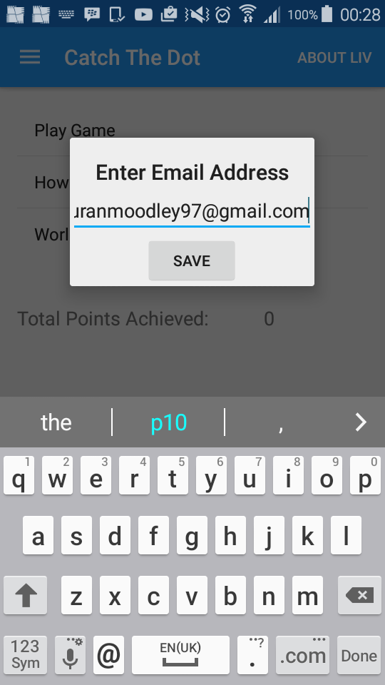

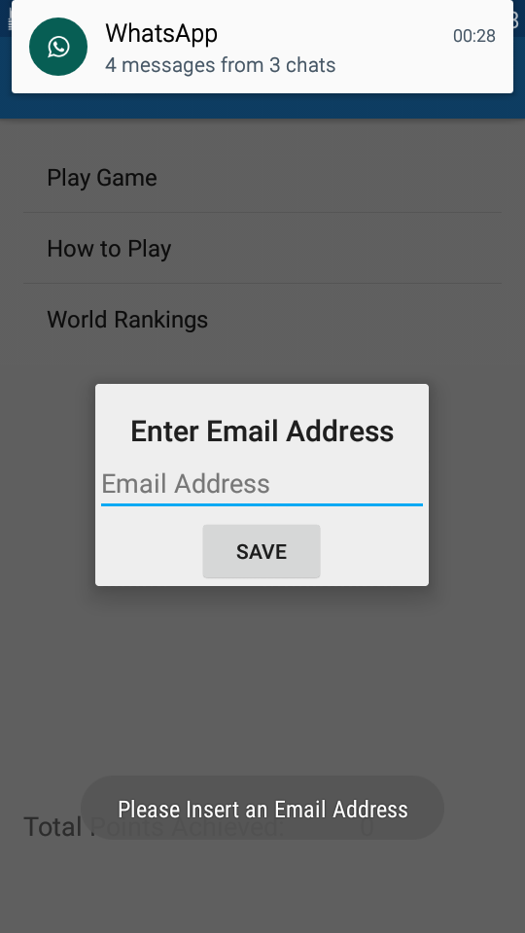 **Main Activity**

*All input is validated. If the user enters the email incorrectly or leaves it empty an error message is shown.*

**Main Activity**

*The player is shown game options with which they can choose from.*

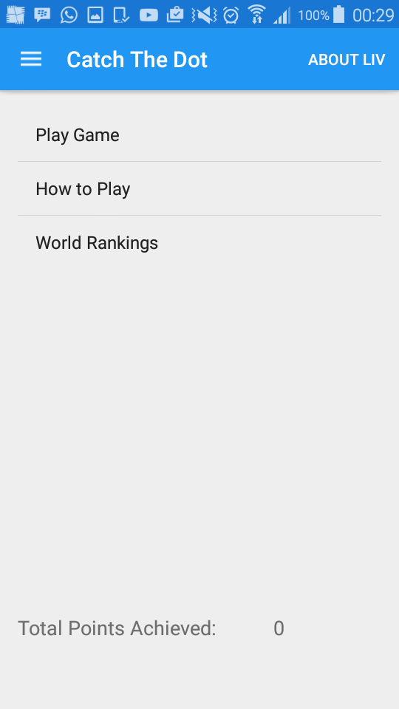

**Main Activity – Navigation Menu**

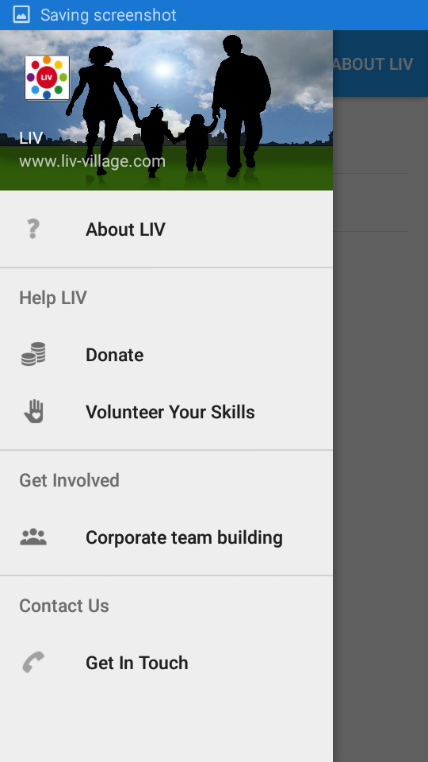*Additional menu options are presented to the user. This gives the user more information about LIV and what they stand for. This is to promote and draw people to LIV.*

**How to Play**

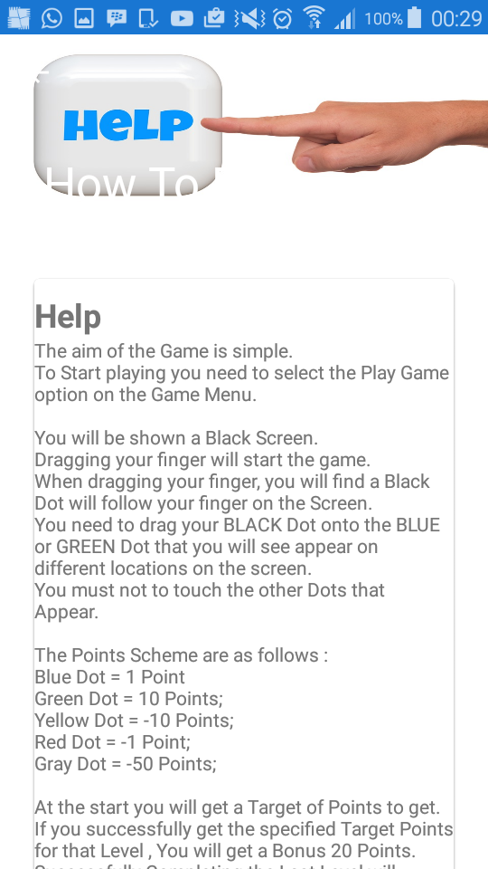 *This presents to player with instructions on how to play the game.*

**About LIV**

*This presents the player with information about LIV and by clicking on the blue button, they can be redirected to the LIV website. The same applies to other screens.*



**Donate**

*This presents the user with further information about how to donate and banking details.*

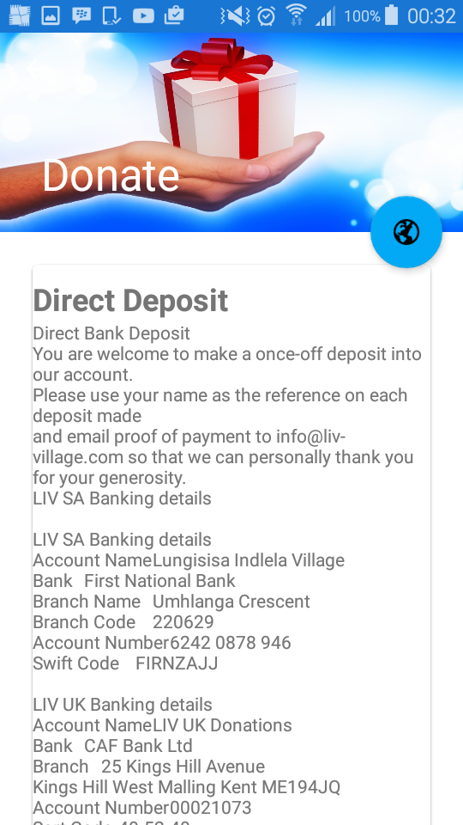

**Volunteer your skills**

*Users who would like to volunteer their skills to LIV can do so by visiting the website to get more information.*

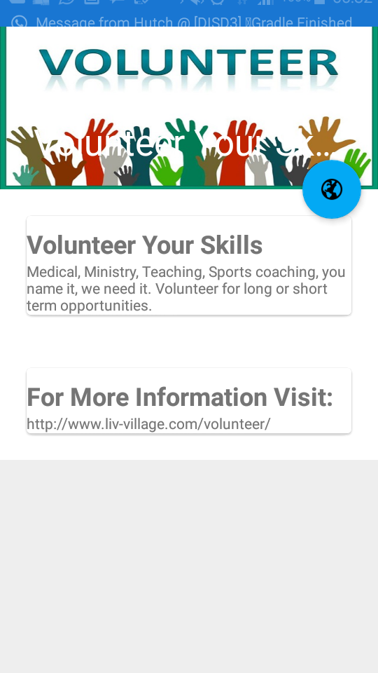

**Corporate Team Building**

*Users are presented with more information about LIV with regards to the social investment initiative.*

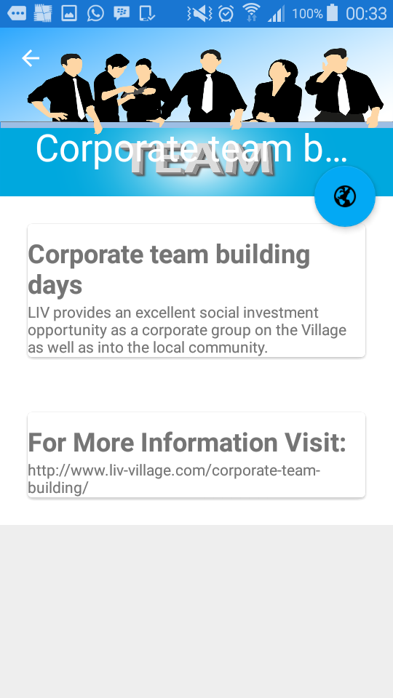

**Contact Us**

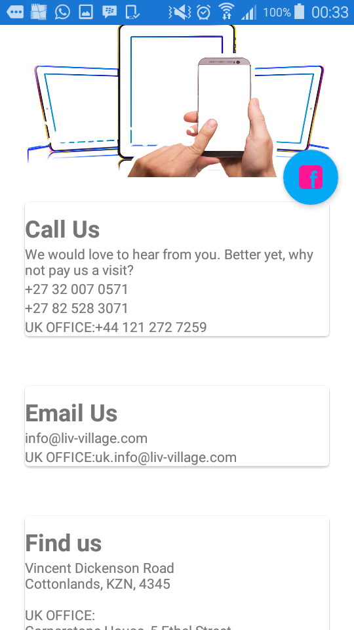

*Users can contact LIV by selecting anyone one of the communication options. Users can also go directly to LIV’s face book page.*

**World Rankings**

*Players can view their scores and where they are ranked in the world. This information is retrieved from the online database and a stored procedure is used to sort users in descending order of their scores.*

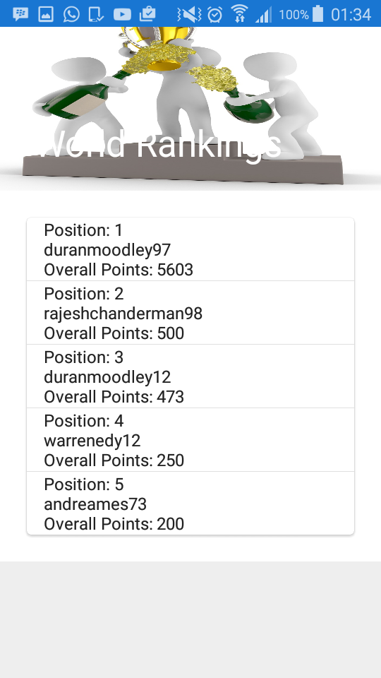

**Game Play**

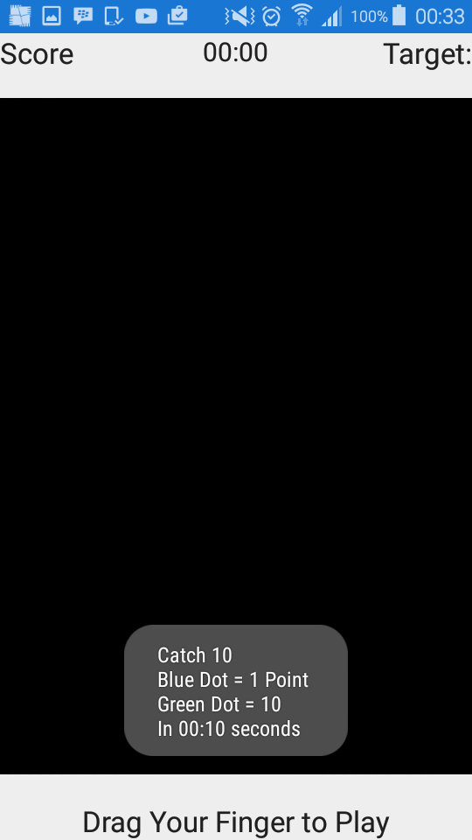*The player can now play the game. The start screen is shown and instructions are shown to the user.*

*To start playing the player must drag their finger on the screen.*

**Game Play**

Game Has Started. Player has touched the correct Dot. The Score has been updated by 10 points, has seen on the top left hand side of the screen. The Black Dot follows/tracks the user finger as he/she moves across the screen.

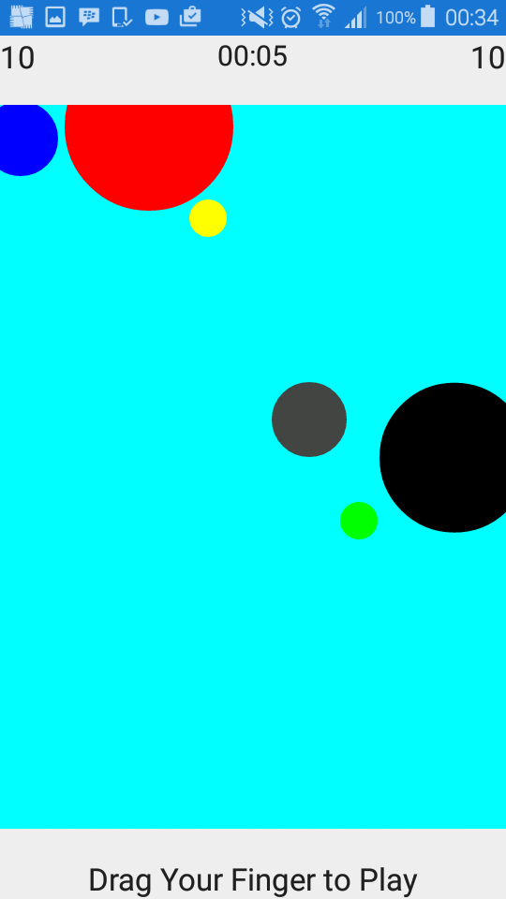

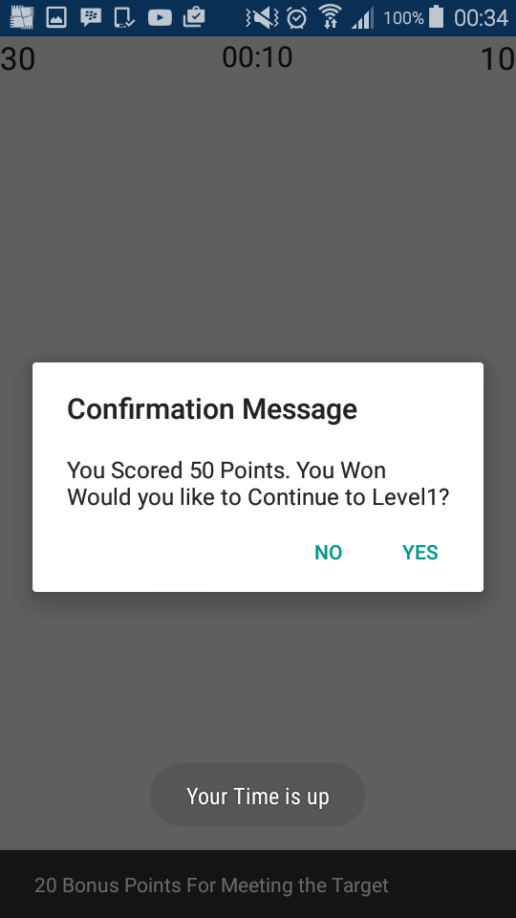

**Game Play**

Player has won the Level by meeting the target points for this level. The player has passed the target of 10 and has been awarded an extra 20 points. Altogether the player has scored 50 points. The player is now prompted to play again and continue to the next level or not.

**Game Play**

*The player has lost the round. He/She has not reached the target of 10 points for this level.*

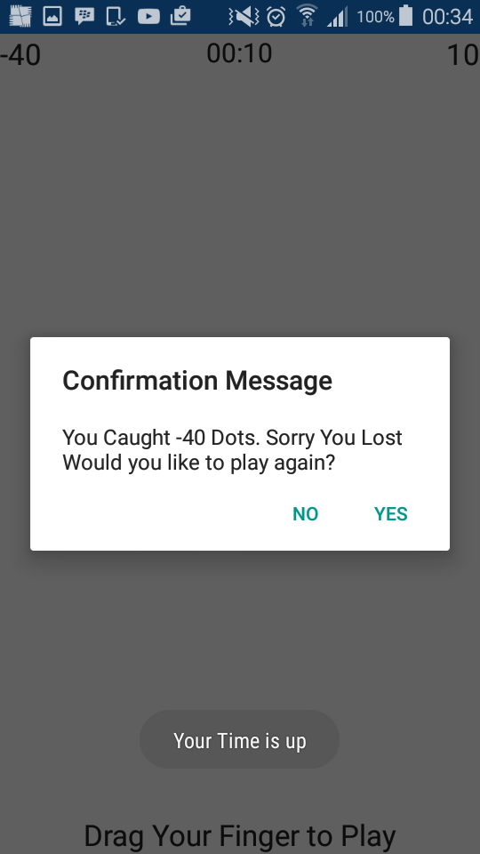

**Game Play**

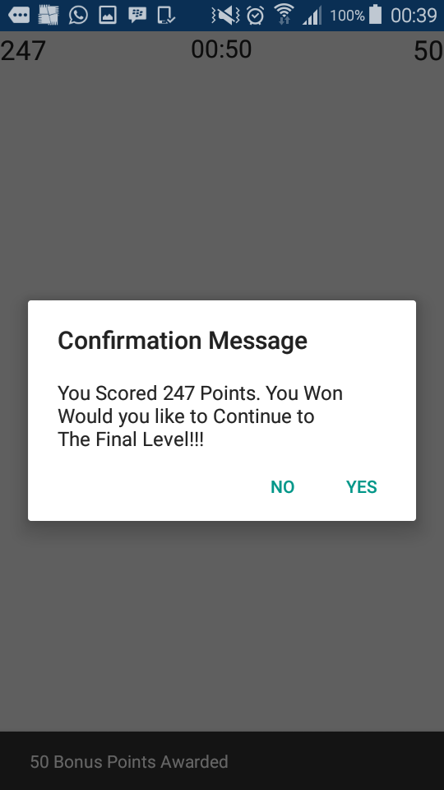*The player has now reached the final level. A Bonus 50 points has been awarded.*

**Game Play**

*All levels are now complete. The Player is prompted to start again and accumulate more points.*

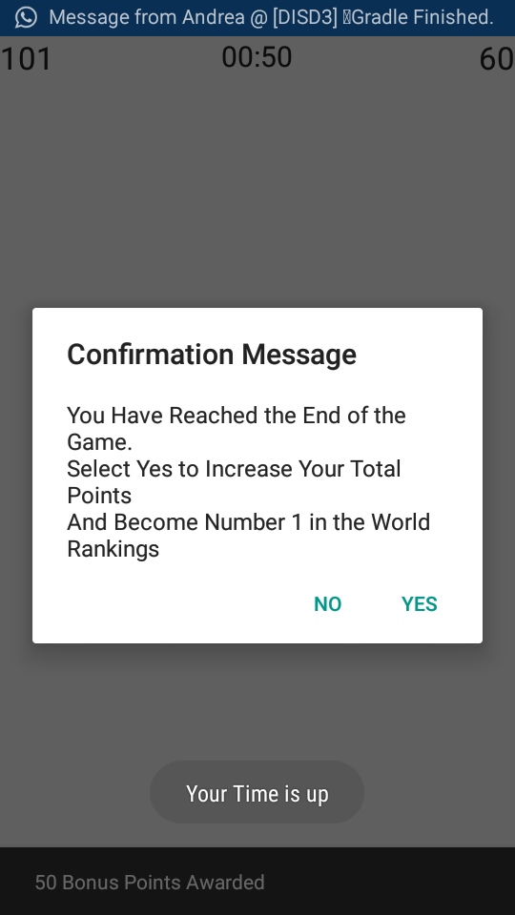

**Main Activity**

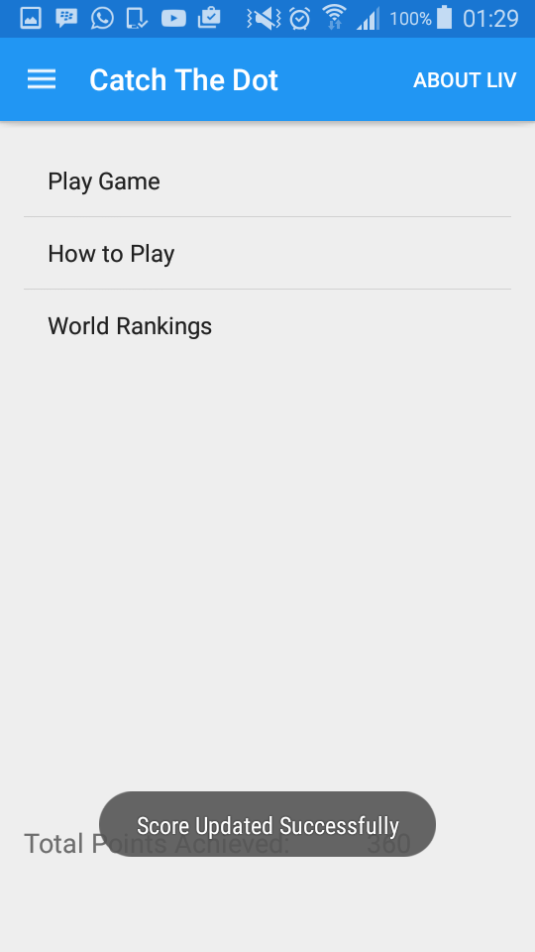 *After each game session, the player score is updated in the online database.*

# Lecturer Feedback & Corrections Made

|  |  |
| --- | --- |
| Lecturer Feedback | Corrections made |
| Email Text box to small and validation is flawed. Try android built in regex next time | Not Fixed. Simple Validation is used. |
| Finger tracking is off quite a bit. This can be improved | Part of the game to challenge the player. |
| You need to add padding to your card views | Content padding added to card views |
| Use material design resources to choose colors | Material design colors have been used. |
| The icons on your action buttons are not good | Material design icon has been added |
| Drawer header image is usually information about the user not the app | Not sure what fix to implement. |
| Poor Design on game activity. | Padding added to improve the design |
| Replace asserts with If statements | Asserts have been replaced with if statements |
| Alert dialog can be put into a class and called when needed together with parameters | Fixed, Class has been created. |
| Some activities are crashing on other devices. Further testing must be done. | Testing was done. Could not find the problem. |

# Conclusion

This app required me to think creatively as I needed to develop an interactive and addictive game. Game development is very challenging but I enjoyed the journey and the challenges that I was presented. I do hope to publish this app to promote the LIV and to attract potential donations.

# 